Summary Table:

| **Use Case Name (Description)** | **ID** | **Related Diagram Use case** |
| --- | --- | --- |
| Warn user if message tone is ambiguous | 1 | **No direct match, add it to the diagram as an extends send message** |
| Allow toggling automatic tone detector | 2 | This is written like a test case, you can keep it just don’t put it on the diagram |
| Request Conversation Tone Summary | 3 | Request Conversation Tone Summary, Give Summary |
| Ask for Clarification | 4 | Ask for Clarification |
| Select Pre-existing Tone | 5 | Select preexisting tone |
| Request Mood update | 6 | No direct match |
| Delete Custom Tone | 7 | No direct match |
| Save Custom Tone | 8 | No direct match |
| Edit Custom Tone | 9 | No direct match |
| Send Message | 10 | Send Message |
| View Messages | 11 | View Messages |
| View Other User's Moods | 12 | View Other User’sMoods |
| Access Indicator Description | 13 | Access indicator description |
| Select Custom Tone | 14 | Select custom tone |
| Manage Bot Settings | 15 | **No direct match** |
| Manage Tone Settings | 16 | **No direct match** |
| Add AI Detected Tone | 17 | Allow toggling automatic tone detector, Request Conversation Tone Summary, Ask for Clarification |

Additional Diagram Use Cases with no direct use case description match:

1. Log In
2. Log Out
3. Specify indication method
4. Select Mood
5. Select preexisting mood
6. Add tone indicator

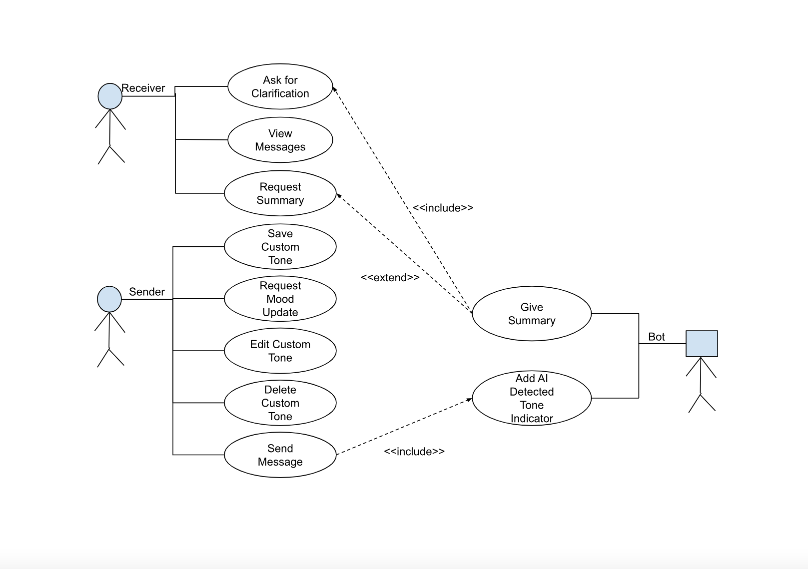

| **Name/Title:** | Warn user if message tone is ambiguous |
| --- | --- |
| **ID:** | 1 |
| **Description**: | As a user (sender), I want to receive alerts when my message may be misinterpreted emotionally so that I can rephrase it for better clarity before I send it |
| **Precondition**: | A message has to be sent |
| **Success Postcondition**: | Warning is given to the user if the message is ambiguous |

| **USER STEPS**:  1. User sends message | **SYSTEM RESPONSE**:  2. System detects the tone of the message as ambiguous  3. System warns the user that the message tone might be ambiguous |
| --- | --- |

| **Name**: | Allow toggling automatic tone detector |
| --- | --- |
| **ID:** | 2 |
| **Description**: | As a user(sender/receiver), I want to be able to toggle the automatic tone detector on and off |
| **Precondition**: | None |
| **Success Postcondition**: | If the toggle is off, then the tone detector is off. If the toggle is on, then the tone detector is on |

| **USER STEPS**:  1. Toggle the automatic tone detector off  3. Go into the message field and send a message  5. Receive a message from someone  7. Toggle the automatic tone detector on  9. Go into the message field and send a message  11. Receive a message from someone | **SYSTEM RESPONSE**:  2. Tone detector displays that it is turned off  4. Tone is not detected  6. Tone is not detected  8. Tone detector displays that it is turned on  10. Tone is detected  12. Tone is detected |
| --- | --- |

| **Name/Title:** | Request a summary of the conversation’s tone |
| --- | --- |
| **ID:** | 3 |
| **Description**: | When a user sees a conversation and isn’t able to get the general nuances of tone over the entire discussion and wants a summary. |
| **Primary Actor**: | Receiver |
| **Goal**: | Allow users to request clarification on a message without their username being shown |
| **Preconditions:** | Messages have been sent, and the receiver wants clarification on the entire/part of the conversation |
| **Postconditions:** | A message containing a conversational tone and other important info has been sent to the user |

Use Case: User requests a summary of the tone for a conversation.

| Actor Actions: | System (Bot) Response: |
| --- | --- |
| 1.1: User enters the channel where the desired conversation has happened or is happening  1.2: User requests summary of tone for conversation through a bot command  3: User enters the starting time  5. User sees the summary and is better able to understand the conversation | 2: The bot asks the user for the initial time of the conversation to find a starting point  4: The bot goes through messages to find the tone   1. The tone is not understood: The bot messages the user to gain clarity on their message, or 2. The tone is within the threshold of confidence and understood   4.1: The bot returns   1. The conversational tone with some messages with low confidence being marked as unsure, or 2. The conversational tone completely understood |

| **Name/Title:** | Ask for clarification |
| --- | --- |
| **ID:** | 4 |
| **Description**: | When a sender sends a message, the receiver can request anonymous clarification of the message’s tone. |
| **Primary Actor**: | Receiver |
| **Goal**: | Allow users to request clarification on a message without their username being shown |
| **Preconditions:** | A message has been sent, and the receiver wants clarification |
| **Postconditions:** | A message is successfully sent to the sender anonymously asking for clarification on a message |

| **USER STEPS**:  1. User uses a slash command to request clarification of a message  4. Anonymized request appears to the sender | **SYSTEM RESPONSE**:  2. System receives request  3: System posts a message to the channel requesting clarification |
| --- | --- |

| **Name/Title:** | Select Pre-existing Tone |
| --- | --- |
| **ID:** | 5 |
| **Description**: | This use case allows users to select predefined moods or tones for their messages to ensure clear emotional communication. |
| **Primary Actor**: | Message Sender (User) |
| **Goal**: | Allow users to draw from a set of preexisting moods or tones |
| **Preconditions:** | User is logged into the system  User has started composing a new message |
| **Postconditions:** | Selected tone is applied to message and visually confirmed for the user (sender) |

| **USER STEPS**:  1. User initiates message composition  3. User selects a tone category (e.g., "Professional", "Friendly", "Urgent")  5. User selects specific tone | **SYSTEM RESPONSE**:  2. System displays available tone/mood categories  4. System displays specific tones within the selected category  6. System applies selected tone indicators to the message  7. System provides visual confirmation of selected tone |
| --- | --- |

## **Alternate Flows**

3a. User wants to customize tone

* User selects "Customize Tone" option
* System displays tone customization interface
* User modifies tone parameters
* System saves custom tone for future use
* Return to step 6 of main flow

4a. User wants to search for specific tone

* User enters tone keyword in search
* System displays matching tones
* Return to step 5 of main flow

## **Exception Flows**

2a. Tone library unavailable

* System displays error message
* System offers basic tone options
* Return to step 3 of main flow

| **Name/Title:** | Request Mood update |
| --- | --- |
| **ID:** | 6 |
| **Description**: | This use case allows a user to request an update of their current mood status from the VC bot. The user can provide a new mood or emotional state, ensuring that their mood is accurately reflected in the server and visible to others. |
| **Precondition**: | The user must be logged into Discord and have access to the VC bot.  The user must request a check in from the bot |
| **Success Postcondition**: | The user’s mood is successfully updated in the system, and the change is reflected in their status for others to see. |

| **USER STEPS**:  1. The user sends a message to the VC bot requesting a mood update.  3. User selects their current mood from a preexisting options, or by customizing their own.  5. User confirms update | **SYSTEM RESPONSE**:  2. The bot prompts the user to select a mood  4. The bot confirms  6. Emotional profile is updated |
| --- | --- |

| **Name/Title:** | Delete Custom Tone |
| --- | --- |
| **ID:** | 7 |
| **Description**: | This use case allows a user to delete a custom tone they previously created in the VC bot. Once deleted, the custom tone will no longer be available for use. |
| **Precondition**: | The user must be logged into Discord and have a custom tone saved.  VC bot must have tone management features enabled for the user. |
| **Success Postcondition**: | The custom tone is successfully deleted and no longer available for future use. |

| **USER STEPS**:  1. The user accesses the VC bot’s menu for tone management.  3. The user selects the custom tone they wish to delete.  5. User confirms deletion | **SYSTEM RESPONSE**:  2. VC bot displays the user’s saved custom tones.  4. VC bot asks for confirmation to delete  6. Tone is deleted from VC bot. |
| --- | --- |

| **Name/Title:** | Save Custom Tone |
| --- | --- |
| **ID:** | 8 |
| **Description**: | This use case allows a user to save a newly created or edited custom tone in the VC bot. Once saved, the custom tone can be used for future messages. |
| **Precondition**: | The user must have created or edited a custom tone using the VC bot’s customization tools.  VC bot must be enabled to save user preferences. |
| **Success Postcondition**: | The custom tone is successfully saved and will b available for future use, allowing the user to apply it to their messages. |

| **USER STEPS**:  1. The user finishes creating or editing a custom tone in the VC bot’s customization menu.  2. The user selects save  3. User confirms | **SYSTEM RESPONSE**:  3. The bot prompts the user with a confirmation to save  4. The bot saves the customized tone. |
| --- | --- |

| **Name/Title:** | Edit Custom Tone |
| --- | --- |
| **ID:** | 9 |
| **Description**: | This use case allows a user to modify an existing custom tone that they have created for use with the VC bot. The user can change parameters such as color, intensity, sound, or vibration to better suit their message tone. |
| **Precondition**: | The user must be logged into Discord and have a custom tone saved that they want to edit.  The VC bot must have tone editing enabled. |
| **Success Postcondition**: | The user successfully edits the custom tone, and the updated tone is applied to their messages moving forward. |

| **USER STEPS**:  1. The user accesses the VC bot’s tone customization menu.  3. The user selects the custom tone they want to edit.  5. The user modifies the desired parameters. | **SYSTEM RESPONSE**:  2. The bot displays the user’s saved tones.  4. The bot opens the tone editor with options to modify color, sound, vibration.  6. The modified tone is saved. |
| --- | --- |

| **Name/Title:** | Send Message |
| --- | --- |
| **ID:** | 10 |
| **Description**: | This use case allows a user to send a message in a Discord channel, with the VibeCheque bot automatically detecting the tone of the message or allowing the user to apply a custom tone to better reflect the intended mood. The message is sent with the appropriate emotional or tonal indicator. |
| **Precondition**: | The user must be logged into Discord and have access to a channel where messages can be sent.  The VibeCheque Bot must be enabled on the server and ready to detect or apply tone indicators. |
| **Success Postcondition**: | The user successfully sends a message, with a tone or mood indicator either automatically detected or manually selected. |

| **USER STEPS**:  1. The user types a message into the Discord chat field  1a. User makes a command to the bot: /customTone  1b. User makes second command to the bot with the custom tone: /*customTone*  3. The user selects the send to post the message. | **SYSTEM RESPONSE**:  2. VC bot automatically detects the tone of the message, or the Select Pre-existing Tone.  4. VC bot attaches the appropriate tone indicator  5. Message is displayed |
| --- | --- |

| **Name/Title:** | View Messages |
| --- | --- |
| **ID:** | 11 |
| **Description**: | This use case allows a user to view messages sent within the Discord server, with the VibeCheque bot applying tone indicators(e.g., color, sound, vibration) or emotional cues to help the user better interpret the tone or mood of the messages. |
| **Precondition**: | The user must be logged into Discord and viewing a channel where messages have been posted.  The VibeCheque bot must be enabled in the server. |
| **Success Postcondition**: | The user views messages in the Discord server, with tone indicators applied to give additional emotional context to messages. |

| **USER STEPS**:  1. The user logs into Discord and accesses the channel they wish to view.  3. User scrolls through the messages  4. The user can select specific messages. | **SYSTEM RESPONSE**:  2. The system displays the messages in the channel with their proper tone indicators.  5. System displays additional details when the user selects a specific message. |
| --- | --- |

| **Name/Title:** | View Other User’s Moods |
| --- | --- |
| **ID:** | 12 |
| **Description**: | This use case allows a user to view the current mood or emotional state of other users when they are connected to the VibeCheque bot on Discord. The moods are either updated manually by the user, or detected automatically by the bot based on message tone analysis. |
| **Precondition**: | Users must be connected to the VibeCheque bot and part of a shared Discord server with other users.   Other users must have their mood visible or have allowed mood sharing. |
| **Success Postcondition**: | Users successfully view the current mood of other users, with mood indicators displayed next to usernames. |

| **USER STEPS**:  1. The User selects the option to view the mood status of other users.  3. The User can scroll through the list of users with visible mood indicators. | **SYSTEM RESPONSE**:  2. The bot displays the list of users with their current mood statuses.  4. The bot updates in real time as any users change their current mood. |
| --- | --- |

| **Name/Title:** | Access Indicator Description |
| --- | --- |
| **ID:** | 13 |
| **Description**: | This use case allows the user to access the indicator description of the tones provided by the VibeCheque bot. The indicator provides information about how the selected tone(e.g., color, sound, vibration) will affect their messages, helping users understand the emotional or tonal impact of their choice. |
| **Precondition**: | The user must have selected a tone or is in the process of customizing one.  The VibeCheque bot must have indicator descriptions enabled. |
| **Success Postcondition**: | The user views the description of the tone indicator, which clearly explains how the tone will affect their message’s appearance and associated cues(e.g., color, sounds, vibrations). |

| **USER STEPS**:  1. User accesses the VibeCheque Bot menu for tone settings  3. User selects a tone they want to learn about. | **SYSTEM RESPONSE**:  2. The bot shows a list of available tones with an option to view the indicator description.  4. The bot gives a detailed description for the chosen tone indicator, explaining its emotional or tonal effects on the message. |
| --- | --- |

| **Name/Title:** | Select Custom Tone |
| --- | --- |
| **ID:** | 14 |
| **Description**: | This use case allows a user to choose a custom tone for their messages on Discord using the VibeCheque bot. The user selects a tone from a predefined list or customizes their own to better reflect the intended mood or emotional state of their communication. |
| **Precondition**: | The User must be logged into Discord and have access to the VibeCheque bot.  The bot must have the “Select Tone” feature enabled for the user. |
| **Success Postcondition**: | The user successfully selects or creates a custom tone, and this tone is applied to their future messages. |

| **USER STEPS**:  1. User accesses the bot’s menu for message tone customization.  3. User selects option to choose or create custom tone  5. The user confirms their selection | **SYSTEM RESPONSE**:  2. Bot presents the user with a list of pre-defined tones and an option to create a new one.  4. Bot allows the user to adjust tone parameters - color, intensity, sound/vibration.  6. Bot saves the custom tone and applies it to future messages. |
| --- | --- |

| **Name/Title:** | Manage Bot Settings |
| --- | --- |
| **ID:** | 15 |
| **Description**: | This use case allows a user to access and modify the settings of the VC bot. The user can personalize the bot’s behavior, such as tone detection preferences, mood update settings, notification preferences, and other customizable options to better fit their communication style and server environment. |
| **Precondition**: | The user must be logged into Discord and have access to VibeCheque bot settings.  The bot must be installed and configure with settings available for personalization. |
| **Success Postcondition**: | The user’s settings are successfully updated, and the VC bot behavior is modified according to the user’s preferences. |

| **USER STEPS**:  1. User opens the VC bot settings menu.  3. User selects the settings they wish to manage, such as tone preferences, mood update intervals, notifications. | **SYSTEM RESPONSE**:  2. Bot displays the available settings  4.Bot saves up the updated settings |
| --- | --- |

| **Name/Title:** | Manage Tone Settings |
| --- | --- |
| **ID:** | 16 |
| **Description**: | This use case allows a user to access and modify the tone detection and application settings of the VC bot. Users can customize how the bot detects, applies, and displays tones(colors, sounds, vibrations) in messages. They can also manage custom tones, default tones, and overall tone sensitivity to align with their communication preferences. |
| **Precondition**: | The user must be logged into Discord and have access to the VC bot.  The VC bot must have tone detection enabled, with customizable settings available for the user. |
| **Success Postcondition**: | The user’s tone settings are successfully updated, and future messages will reflect the changes in tone detection and customization. |

| **USER STEPS**:  1. User opens the VC bot’s tone settings menu.  3. User adjusts the tone detection settings or adds, edits, or deletes custom tones | **SYSTEM RESPONSE**:  2. Bot displays the available settings  4.Bot saves up the updated settings |
| --- | --- |

| **Name/Title:** | Add AI-Detected Tone Indicator |
| --- | --- |
| **ID:** | 17 |
| **Description**: | This use case allows a user to type a message, which will then automatically have its tone detected by the AI. The user will not have to select a tone themselves. |
| **Precondition**: | The user must be logged into Discord and have access to the VC bot.  The VC bot must have tone detection enabled. |
| **Success Postcondition**: | The user’s tone settings are successfully updated, and future messages will reflect the changes in tone detection and customization. |

| **USER STEPS**:  1. The user sends a message | **SYSTEM RESPONSE**:  2. The bot, through ai detection, detects and labels a tone to the message |
| --- | --- |